**GEOM 2007 Project – Siting for New School in Central Ottawa Area**

Yubin Zhou

100889724

Dec 08, 2015

**Project Design:**

**Goal:**

Population is increasing dramatically today, public facilities are not sufficient for

Canadian citizens. School is one of these, current existing school does not meet the

needs of people. The goal of this project is find a site for a new school in central Ottawa

area. The new school location should not close to current existing school, but it should

near transit route and near residential area. Also, the area in Ottawa that have higher

amounts of population of age under 18 should have higher demand for school, so this

area will be a better location for building new school. The result of my project will

produce a raster file(.tif) that indicate the suitable area for a new school, the range of

this area are all good to build a new school, but if the value of location is higher, that

means it is more appropriate location to build a new school.

**Data Sources(All file name list below except 2EdLEvlrI5OSuO_data contain .cpg .dbf .prj .shp .shx file):**

City_Boundary_2001, From Practical test of GEOM 2007, Author Chuiqing Zeng

gct_505b11a, <https://library.carleton.ca/find/gis/geospatial-data/ottawa-gatineau-census-geography-files,statistic>, Statistics Canada(Carleton [Maps, Data and Government Information Centre](https://library.carleton.ca/contact/service-points/maps-data-and-government-information-centre))

Land_Use, From Practical test of GEOM 2007, Author Chuiqing Zeng

TransitRoutes_2014, <https://library.carleton.ca/find/gis/geospatial-data/oc-transpo-transit-routes>, Carleton [Maps, Data and Government Information Centre](https://library.carleton.ca/contact/service-points/maps-data-and-government-information-centre)

School_All_Fall2002, <https://library.carleton.ca/find/gis/geospatial-data/ottawa-thematic-data>, Carleton [Maps, Data and Government Information Centre](https://library.carleton.ca/contact/service-points/maps-data-and-government-information-centre)

2EdLEvlrI5OSuO_data, http://dc1.chass.utoronto.ca.proxy.library.carleton.ca/census/, Carleton [Maps, Data and Government Information Centre](https://library.carleton.ca/contact/service-points/maps-data-and-government-information-centre)

**Steps:**

1. Buffer Schools_All_Fall2002 shapefile to get a new polygon shapefile called School_1000m_buffer with area within 1000 meters from all school points.
2. Use symmetric difference tool to get new polygon shapefile called outside_school with area that not within distance 1000 meters from every school in Ottawa.
3. Use buffer tool to get area that within 500 meters from OCTranspo routes and output a new polygon shapefile called within_transit_500m.
4. Use intersect tool to find intersection area between outside_school shapefile and within_transit_500m shapefile, that means find the area that are within 500 meters from transit route and not within 1000 meters from school, the output new shapefile is called near_transit.
5. Using select tool and SQL to get residential area from Land_Use shapefile, output shapefile called Residential_area.

1. Using buffer tool to get area that within 1000 meters from all residential area(Residential_area.shp) in ottawa, output new shapefile called within_residential_1000m.
2. Getting a new shape file called School_Location by using intersect tool to find area that not within 1000 meters from current school location, within 500 meters from all OCTranspo transit routes and within 1000 meters from current residential area in Ottawa.
3. Produce a distance from current schools raster file by using Euclidean Distance tool, Schools_All_Fall2002 as input file, output distance_from_school raster file.
4. Get population of Canadian citizens aged under 18 from website and download it.
5. Add data into gct_505b11a by right click layer and using join tool, join 2EdLEvLrI5OSuO_data file into gct_505b11a shapefile according to attribute CTUID, then save it to a new shapefile called gct_new
6. Use clip tool to clip gct_new shapefile with updates feature City_Boundary_2001 shapefile, output gct_clip shapefile.
7. Convert shapefile to raster file by using Feature to Raster tool, so convert gct_clip shapefile to a raster file called gct_raster.
8. Using raster calculator tool to put different weight in distance_from_school raster file, gct_clip raster file and combine them into one raster file called recalculation_raster raster file.
9. Clip the recalculation_raster file with according to the boundary of School_Location shapefile and output the final result called final_result_schoollocation raster file.

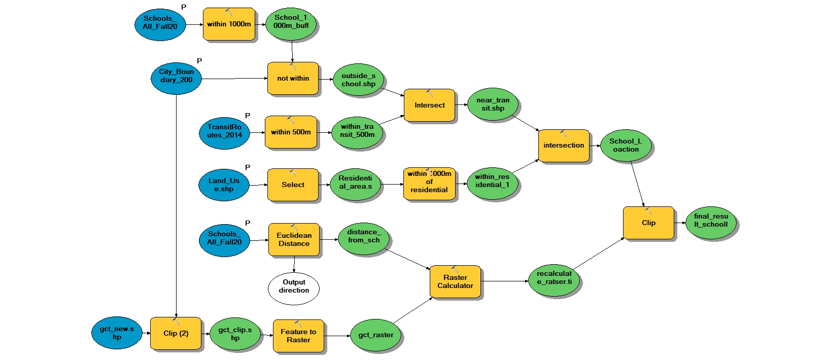

**Data:**

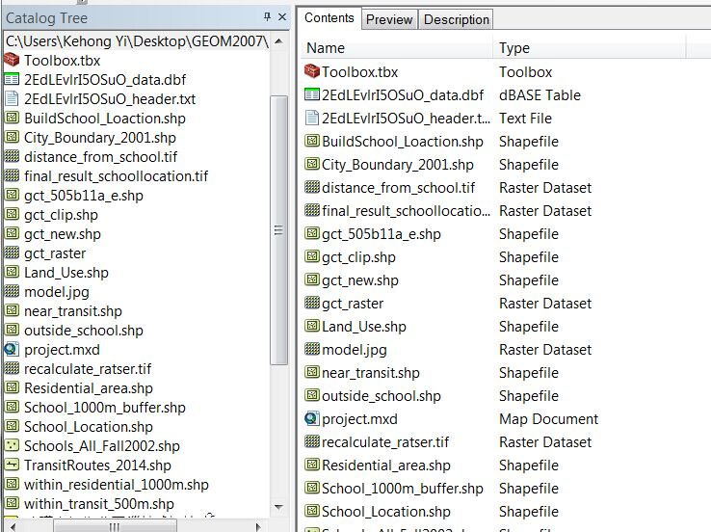

**Table for all layers show in map**

|  |  |  |  |  |  |  |
| --- | --- | --- | --- | --- | --- | --- |
| Layer name | Number of Records | Length_km | Area_Sqm | Area_Sqkm | Perimeters_m | Perimeters_km |
| Schools(point) | 337 |  |  |  |  |  |
| OCTranspo Route(polyline) | 160 | 3366.81 |  |  |  |  |
| Residential Area(polygon) | 16965 |  | 101598887.02 |  | 5124159.47 |  |
| Census Tract(polygon) | 209 |  |  | 2814.99 |  | 2313.98 |
| Best Location for New School(Raster) |  |  |  |  |  |  |

**Schools layer(point):**

Schools layer is a point shapefile, it indicates where school locate in this map. There are 8 fields in this table, they are FID, Shape, CATEGORY, NAME, NUM, STREET, CITY_PROV, POSTAL. The symbology I choose for schools layer is Tourmaline Green point.

FID - id of records,

Shape – the type of shape of the record

CATEGORY – the type of school (e.g Elementary)

NAME – name of the school

NUM – street number of the school location

STREET – street name of the school location

CITY_PROV – city name and province name of the school location

POSTAL – postal code of the school

**Sample attribute table of Schools layer**

|  |  |  |  |  |  |  |  |
| --- | --- | --- | --- | --- | --- | --- | --- |
| FID | Shape | CATEGORY | NAME | NUM | STREET | CITY_PROV | POSTAL |
| 59 | point | Elementary | Georges Vanier Catholic E.S. | 40 | prom. Varley Dr | Kanata (On) | K2K 1G5 |
| 60 | point | Elementary | Good Shepherd Catholic E.S. | 101 | chemin Bearbrook Rd | Gloucester (On) | K1B 3H5 |
| 61 | point | Elementary | Holy Cross Catholic E.S. | 2820 | prom. Springland Dr | Ottawa (On) | K1V 6M4 |

**OCTranspo Route layer(polyline):**

Datum: D_North_American_1983

OCTranspo Route layer is a polyline shapefile, it indicates all OCTranspo routes in Ottawa area.

There are 6 fields in this layer, they are FID, RTE_NUM,RTE_TYPE,MODE,YEAR,Length_km. The symbology I choose for this layer is Delft Blue line.

FID – id of the record

RTE_NUM – route number of the record

RTE_TYPE – route type of the record

MODE – the transportation mode of the record

YEAR – year of the record

Length_km – the length of the route

**Sample attribute table of OCTranspo Route layer**

|  |  |  |  |  |  |
| --- | --- | --- | --- | --- | --- |
| FID | RTE_NUM | RTE_TYPE | MODE | YEAR | Length_km |
| 0 |  | OTRAIN | Train | 2014 | 7.99 |
| 1 | 6 | Peak Route | Bus | 2014 | 5.54 |
| 2 | 96 | Limited Service | Bus | 2014 | 0.15 |
| 3 | 99 | Regular Route | Bus | 2014 | 5.94 |

**Residential Area layer(polygon):**

Datum: D_North_American_1983

Residential Area layer is a polygon shapefile, it indicates all the residential area in the Ottawa area. There are 5 fields in this layer, FID, ID, LU_95, Area_Sqm, Perimeters_m. The symbology of this layer is Coral polygon.

FID – id of the records

ID – id of residential location

LU_95 – type of residential area

Area_Sqm – area of the record

Permeters_m – permeters of the record in units of meter

**Sample attribute table of Residential Area layer**

|  |  |  |  |  |
| --- | --- | --- | --- | --- |
| FID | ID | LU_95 | Area_Sqm | Perimeters_m |
| 0 | 1750085 | Residential: Single Detached | 12368.96 | 485.16 |
| 1 | 1750077 | Residential: Single Detached | 24195.18 | 850.65 |
| 2 | 1750075 | Residential: Row and Townhouse | 41048.79 | 1022.56 |

**Census Tract layer(polygon):**

Datum: D_North_American_1983

Census Tract layer is a polygon shapefile, it indicates all the tracts in the Ottawa area and show its population in the tract. There are 8 fields in this layer, FID, CTUID, CTNAME, CMANAME, PRNAME, Population_Under 18, Area_Sqkm, Perimeters_km. The symbology of this layer is graduated colors with green color from the shallow to the deeper.

FID – id of the record

CTUID – id of the census tract

CTNAME – the name of census tract

CMANAME – the name of the city where census tract located

PRNAME – the province’s name of the record located

Population_Under 18 – population number of Canadian citizens age under 18 in census tract

Area_Sqkm – area of census tract in units of square kilometer

Permeters_km – perimeters of census tract in units of kilometer

**Sample attribute table of Census Tract layer**

|  |  |  |  |  |  |  |  |
| --- | --- | --- | --- | --- | --- | --- | --- |
| FID | CTUID | CTNAME | CMANAME | PRNAME | Population_ Under 18 | Area_Sqkm | Perimeters_km |
| 0 | 5050151.08 | 151.08 | Ottawa - Gatineau (Ontario part / partie de l'Ontario) | Ontario | 1600 | 12.91 | 21.06 |
| 1 | 5050103 | 103 | Ottawa - Gatineau (Ontario part / partie de l'Ontario) | Ontario | 450 | 0.84 | 4.14 |
| 2 | 5050170.04 | 170.04 | Ottawa - Gatineau (Ontario part / partie de l'Ontario) | Ontario | 650 | 1.34 | 4.65 |

**Best Location for New School(raster dataset):**

Best Location for New School layer is raster dataset, it is the final result of my project, it indicates the recommend area that can build a new school. The value of the location more higher or the color of location more deeper, that means this is a better location to build school.

**Map:**

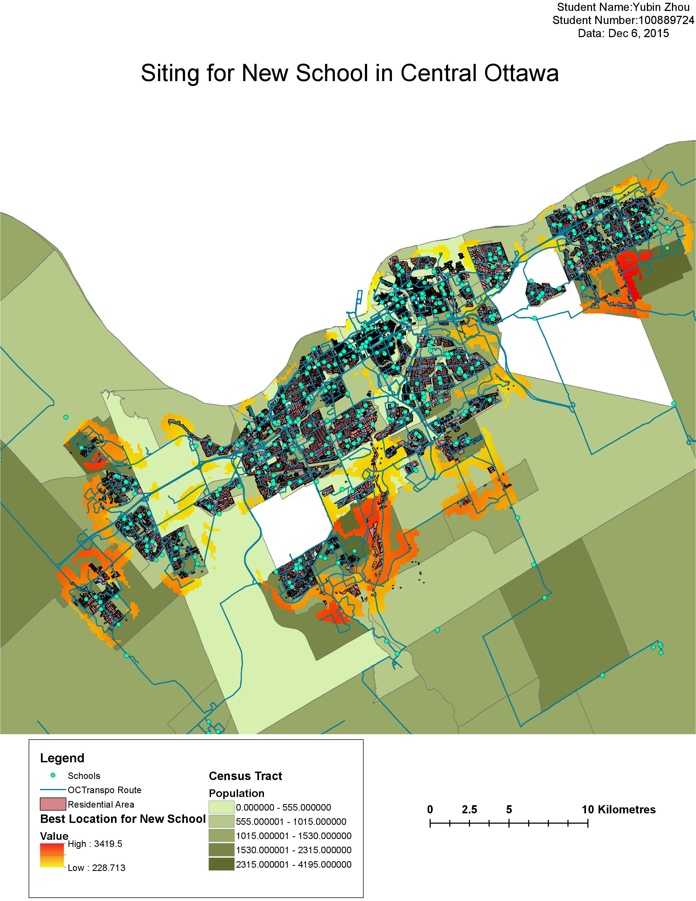

**User Guide:**

Once you open the project.mxd file, then all 5 layers are label at “Table of Contents”. User can open attributes table to find some useful information of the layer. All produce steps are included in the modelbuilder file and it is in the Toolbox.tbx, User may change some steps or change input parameter according to their requirement.